**POM Class 3**

**Functional Organization:**

* Grouped into departments (finance, production, sales, analysis, design, testing…)
* Every department addresses an activity (function)
* Properties:
  + Projects are pipelined through the departments (from research, then development..)
  + Different departments have identical needs (IT infrastructure, Configuration mgt.)
  + Only few participants are completely involved in a single project

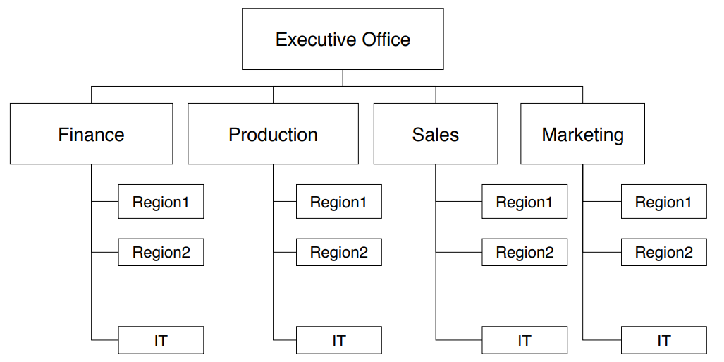

**Advantage:**

* Members have a good understanding of their area

**Disadvantages:**

* Difficult to make major investments
* High chance for duplication of work

**Project-based organization**

People are assigned to a project, each of which has a problem to be solved in a certain time within a given budget

**Key** **Properties**:

* Teams are assembled when a project is created
* Every project has a project manager
* A participant is involved in a single project only

**Advantages**:

* Responsive to new requirements (the project can be tailored around the problem)
* New people can be hired who are familiar with the problem
* No idle time for project members (Wartezeit)

**Disadvantages**:

* Difficult to assemble a team
* Roles and responsibilities need to be defined at the beginning

**When to use it:**

* Project has high degree of uncertainty
* Open communication is needed among participants
* Requirements are expected to change during the project
* New technology that could effect the outcome may appear during the project

**Flat vs. Gradual staffing**

**Gradual staffing**: Ramped up by hiring people as needed. It is motivated by saving resources at the early parts of the project.

**Flat staffing**: All participants are assigned at the start of a project. Taken from a pool of available people

**Matrix Organization**

People from different departments of a functional organization are assigned to work on one or more projects (less then 100% of their time in one project)

**Advantages**:

* Teams for projects can be assembled rapidly from the departments
* Expertise can be applied to different projects as needed
* Consistent reporting and decision procedures can be used for projects of the same type

**Disadvantages**:

* Team members are often not familiar with each other
* Team members have different working styles
* Team members must get used to each other

**Challenges:**

* Team members working on multiple projects have competing demands for their time
* Multiple work procedures and reporting systems are used by different team members
* “**Double-boss problem**”: team members must respond to two different bosses with different focus:
  + Focus of the department manager: assignments to different projects, performance appraisal
  + Focus of the project manager: work assignments to project members, support of the project team, deliver project in time and within budget
* Department and project interests might be in conflict with each other

**Project organization structures**

* **Decision structure**: Models the control flow: Who decides what?
* **Reporting structure**: Who reports their status to whom?
* **Communication structure**: Models the information flow: Who facilitates communication with whom? An org-chart maps these 3 structures on a graph with a single relationship
* A non-hierarchical project organization keeps these 3 structures separate

**Line organization problem:**

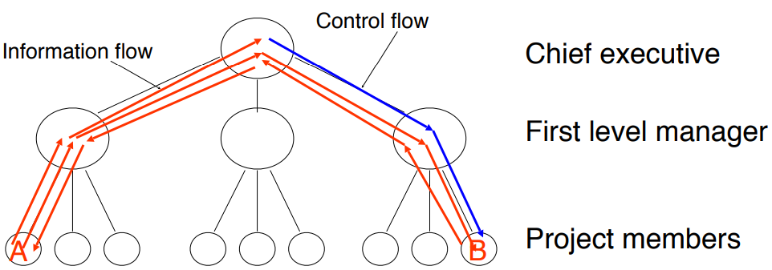

* Information flow in a hierarchical project organization does not work well with unexpected changes
* The manager is not necessarily always right and might even misunderstand communication requests
* Improving information flow through non-hierarchical project organizations
  + Cutting down on bureaucracy (direct communication is possible)
  + Reduces development time
  + Decisions are expected to be made at each level
  + Hard to manage (who is in control in case of conflicts?)

**Communication skills**

A software project manager as well as a software engineer needs to acquire several **skills**:

* **Collaboration**: negotiate requirements with the client and with members from your team
* **Presentation**: present a major part of the system during a review
* **Technical writing**: write part of the proposal, part of the project documentation
* **Management**: facilitate a team meeting, find compromises, negotiate between conflicting demands
* **Communication** is critical for the success
* The project manager needs to distinguish the following modes of communication (also called communication events):
  + Planned communication
  + Event-driven communication
* A project manager needs to understand the difference between communication events and communication mechanisms

**Communication event vs. mechanism**

**Communication event**: information exchange with defined objectives & scope

* **Scheduled**: planned communication
* **Unscheduled**: event-driven communication. Examples: request for change

**Communication mechanism**: tool or procedure that can be used to deal with a communication event

* **Synchronous**: same time
* **Asynchronous**: different time

Communication Event is supported by Communication Mechanism

Seite 33 ??????

**Communication mechanisms**

Synchronous examples:

* **Informal Meeting**:
  + Ex. Meeting at the water cooler
  + Unplanned conversation
  + + Cheap and effective for resolving simple problems
  + - Information loss, missunderstandings
* **Formal Meeting**
  + Ex. Face to face, video conference
  + Planned conversation, project rewievs…
  + + Effective for resolving issues
  + - High costs

Asynchronous examples:

* Email
* Chats
* Wikis

UML View of project management basics

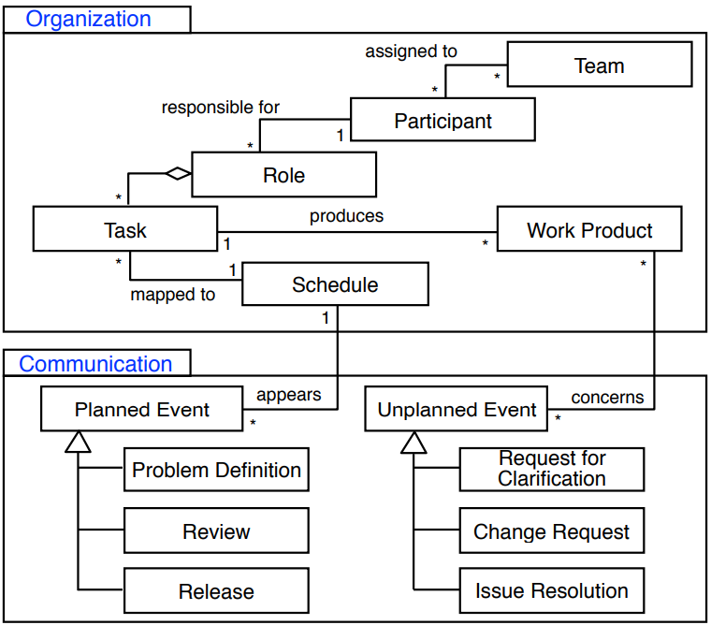

**Meeting management**

* Procedure to plan and ensure productive meetings
* It allows meetings with a constant level of quality and a structured process
* It provides templates, roles and guidelines

**Importance of meeting management**

* As a manager you need to know how to apply meeting management
* You need the ability to illustrate the benefits of the meeting procedures to achieve efficient meetings
* Review systematically the agendas and minutes in the first weeks of a project
* Suggest time-saving improvements to the facilitators and the minute takers

**Meetings**

* A team should meet at least once a week
* Scrum Teams meet daily in short standup meetings (15min)
* Use a structured agenda
* Team members share important information and make it accessible to all participants (meeting minutes)
* Every participant is aware of his/her role in the meeting

Meeting Roles:

**Primary Facilitator:**

* Organizes the meeting
* Creates the agenda
* Guides the meeting as moderator
* Makes sure the participants follow the structure of the agenda but be flexible for changes

**Minute Taker:**

* Creates meeting minutes (Protokoll) during the meeting
* Writes down all important information and decisions
* Distributes the minutes to all participants latest one day after the meeting

**Time Keeper**:

* Keeps track of the time
* Makes sure the time limits are met
* Is allowed to interrupt any person in the meeting (when someone talks to long)

**Post mortem analysis**

* Also called project retrospective
* Empirical study method in software engineering to get knowledge about past projects
* Performed soon after the most important milestones or at the end of the project
* A post mortem analysis reveals problems and solutions more frequently and differently than project completion reports alone.

**Software Project Management Plan**

**Software Project**

* A software project has a specific duration, schedule, consumes resources and produces work products
* All technical and managerial activities required to deliver the deliverables to the client

**Software Project Management Plan (SPMP)**

* The controlling and planning document for a software project
* Specifies the technical and managerial approaches to develop the software product
* Companion document to the requirements analysis document (RAD) and system design document (SDD): Changes in one of these 3 documents imply changes in the other 2 documents

**Project Agreement**: A document written for a client that defines:

* Scope, duration, cost and deliverables for the project
* Exact items, quantities, delivery dates, delivery location

**Client**: Individual or organization that specifies the requirements and accepts the project deliverables

**Deliverables**: Work Products to be delivered to the client

The form of a project agreement can be a contract, a statement of work, a business plan, or a project charter

Folie 93, 95???

**Summary**

- **Meeting Management** is important, but often neglected

* An **agenda** helps the participants to prepare for the meeting
* A **protocol** helps the participants to lookup important information and decisions
* As a manager, you are responsible to create an open and efficient atmosphere

- There are three rotating roles: primary facilitator, minute taker, time keeper

-Confluence allows to

* Collaboratively manage meetings
* Include JIRA issues in the status and as new action items

- A **project** is a scheduled effort towards the achievement of a goal that takes place within a limited time, resources and budget

- Project participants are organized in terms of **roles** and **teams** (an individual can fill more than one role)

- Work is organized in terms of **activities** and **tasks** assigned to roles to produce **work** **products** such as deliverables

- 3 types of **project** **organizations**: functional, matrix and project-based organization.

- 3 structures to deal with information and control flow in a project: **Decision**, **reporting** and **communication** **structure**

- **Communication** **Events**: planned and unplanned (driven by unexpected events)

- There are asynchronous and synchronous **communication** **mechanisms** (tools or procedures) to support communication events